**Title:** Delayed trophic response of a marine predator to ocean condition and prey availability during the past century

**Running Title:** Delayed predator trophic response

**Authors:** Megan L. Feddern1, Gordon W. Holtgrieve1, Eric J. Ward2

1. University of Washington, School of Aquatic and Fishery Sciences, 1122 NE Boat Street, Seattle, WA 98105

2. Conservation Biology Division, Northwest Fisheries Science Center, National Marine Fisheries Service, 2725 Montlake Boulevard East, Seattle, WA 98112

**Corresponding Author:** Megan L. Feddern, 603-651-6802, mfeddern@uw.edu

**Open Research Statement:** (3) Harbor seal stable isotope data are provided as private-for-peer review on a repository [available here](https://datadryad.org/stash/share/C8W7Xra6PUBYHgkxlPauU41q9P3PdpQO9xAU9tj4Dko). Upon publication data will become public with a permanent doi hosted through Dryad. (2) Some data are already published and publicly and the sources are described in the supplementary material.

**Abstract**

Understanding the response of predators to ecological change at multiple temporal scales can elucidate critical predator-prey dynamics that would otherwise go unrecognized. We performed compound-specific nitrogen stable isotope analysis (CSIA) of amino acids on 153 harbor seal museum skull specimens to determine how this marine predator has responded to ecosystem change over the past century. The relationships between harbor seal trophic position, ocean condition, and prey abundance, were analyzed using hierarchical modelling of a multi-amino acid framework and applying 1-, 2-, and 3- year temporal lags. We identified delayed responses of harbor seal trophic position to both physical ocean conditions (upwelling, sea surface temperature, freshwater discharge) and prey availability (Pacific hake, Pacific herring and Chinook salmon). However, the magnitude and direction of the trophic position response to ecological changes depended on the temporal delay. For example, harbor seal trophic position was negatively associated with summer upwelling, but had a 1- year delayed response to summer sea surface temperature, indicating some predator responses ecosystem change are not immediately observable. These results highlight the importance of considering dynamic responses of predators to their environment as multiple ecological factors are often changing simultaneously and can take years to propagate up the food.

**Keywords**

*Stable isotope, trophic position, harbor seal, amino acid, Washington, Salish Sea, Chinook salmon, Phoca vitulina, Pacific herring, Columbia River, sea surface temperature*

**Introduction**

The regulation of food web structure by resources (bottom-up control) is fundamental for understanding food web responses to environmental, ecological, and anthropogenic change (Carpenter et al. 1985, Hunter and Price 1992, Estes et al. 1998). Ecological communities are continuously experiencing both biotic and abiotic disturbances (Paine et al. 1998) and the ability of food webs to dynamically respond to these changes is crucial for ecosystem stability (Ghedini et al. 2015). In marine food webs, physical ocean conditions can impact primary production and ultimately constrain energy availability and thus biomass at higher trophic levels (Ware and Thomson 2005, Chassot et al. 2010, Moore et al. 2018). Large-scale changes in nutrient availability (Rykaczewski and Dunne 2010), primary productivity (Chassot et al. 2010), and top predator abundance over the past century (Magera et al. 2013) means many food webs are experiencing shifts in multiple mechanisms of regulation in tandem. However, impacts of ecological change do not immediately propagate through the complete food web (Duguid et al. 2019, Smith et al. 2017) making it challenging to identify dominant drivers structuring food webs over the long term.

Historical marine predator data that span multiple environmental, ecological, and anthropogenic contexts are useful for identifying time scales over which predators respond to ecosystem drivers. Compound-specific stable isotope analysis (CSIA) of amino acid nitrogen can serve as a tracer of historical predator response to ecological and environmental change by deriving retrospective trophic position estimates from museum specimens (McMahon et al. 2019, Feddern et al. 2021). Source amino acids (i.e., phenylalanine, lysine, methionine) exhibit minimal trophic discrimination (the difference in 15N/14N between trophic and source amino acids in consumers from a trophic transfer) and thus are a proxy for the nitrogen stable isotope signature of primary producers at the base of the food web. In contrast, trophic amino acids (i.e., alanine, glutamic acid, valine, proline) demonstrate trophic enrichment (McMahon and McCarthy 2016) that varies for individual amino acids. Combined, this approach allows for reconstruction of historic trophic position estimates under changing environmental conditions when characterizing the isotopic baseline of past ecosystems may not be possible (McMahon et al. 2019). Thus, CSIA is well suited to identify long-term drivers of food web dynamics when analyzed with historic indices of ocean condition and prey availability.

Reconstructing time series of predator trophic position requires careful consideration of physiological and ecological parameters that contribute to stable isotope values. First, taxa exhibit different trophic enrichment factors based on excretion pathways, diet type (omnivory, herbivory, carnivory), and growth (Nielsen et al. 2015). Second, the nitrogen production pathway of vascular (i.e., seagrasses) versus nonvascular (i.e., marine diatoms) primary producers impart distinct stable isotope fractionation factors (referred to as *β*) as inorganic sources of nitrogen are converted to tissues (Ramirez et al. 2021). Assumptions about the relative contributions of vascular versus nonvascular plants can therefore impact trophic position estimates (Choi et al. 2017). Finally, there is a delay between the time a prey source is consumed and when that prey source has been fully assimilated by (and thus measurable in) the consumer, referred to as the ‘turnover time’. Turnover times must be considered when comparing trophic position data to ocean condition and prey availability covariates, as the consumer response to an ecological change will not be immediately observable in consumer tissues.

Nearshore coastal ecosystems provide a model system to assess long-term changes of food web drivers using archival museum specimens of a marine predator by applying CSIA. Food webs of coastal Washington and the Salish Sea have experienced dramatic restructuring over the past century due to declines and subsequent recoveries of marine predators (Jeffries et al. 2003, Ohlberger et al. 2019). Decades of state-financed population control programs resulted in harbor seals (*Phoca vitulina*) reaching a historic low in the 1970's, with an estimated abundance of approximately 1,000 individuals (Jeffries et al. 2003). Following the cessation of bounties in 1960 and the passage of the Marine Mammal Protection Act in 1972, top-predator abundance increased dramatically. Benefitting from a relatively legislation restricting mortality, short life history, and a generalist diet harbor seal populations increased 10-fold between 1970 and 2003 (Jeffries et al. 2003). The increase in abundance of this top predator has been implicated in the declines in economically and ecologically important prey species in the region (Chasco et al. 2017, Nelson et al. 2019), specifically, Chinook salmon (*Oncorhynchus tshawytscha*). Chinook salmon are listed as endangered in the region (WDFW 2017) and are an important prey species for the endangered southern resident orca (Marshall et al. 2015). Simultaneously, the region has also experienced changes in nutrients (Mohamedali et al. 2011), climate regimes (Corwith and Wheeler 2002, Mantua and Hare 2002) and abundances of other important prey species such as Pacific herring (*Clupea pallasii*, Siple and Francis 2016).

Here we examined a century of harbor seal trophic position data in coastal Washington and the Salish Sea. The objective of this work is to identify the time scales at which physical ocean conditions and prey availability exert bottom-up control on marine food webs as indicated by predator trophic position. We assumed a correlation between trophic position and prey species abundance is the result of increased or decreased consumption of that species. Simlarly we assume a correlation between trophic position and ocean condition indicates an environmentally induced change in food web structure the alters harbor seal prey availability. Additionally, we established a multi-amino acid framework for measuring trophic position that improves precision and ecological accuracy by applying a species-specific trophic discrimination factor (McMahon et al. 2019, Nielsen et al. 2015). We also included a system specific *β* rather than a universal value, and applied temporal lags to account for both physiological and ecological delays in consumer response.

**Methods**

*Sample collection and analysis*

Samples were obtained using methods described in Feddern et al. (2021). Briefly, harbor seal bone was obtained from four museum institutions (the Burke Museum, the Slater Museum, the Royal British Columbia Museum, and the Smithsonian Institute) and the National Marine Mammal Laboratory (NOAA) (Appendix S2: Table S1). Specimens were treated by maceration in warm water and stored in acid free boxes. Sampling targeted adult specimens and prioritized long-term temporal coverage in two main regions: coastal Washington and the Salish Sea (which included 18 specimens from British Columbia). Specimens with sex, length, age, and month of collection data were also prioritized but this information was not available for all sampled specimens. Cause of death was not available for all specimens but most adult and subadult strandings in the region are the result of trauma (i.e., fishing entanglements, boat strikes) or infectious disease as opposed to malnutrition (Warlick et al. 2018, Ashley et al. 2020). A total of 153 specimens were sampled with field collection dates ranging 1928-2014 (Figure 1).

*Trophic position determination*

Bone collagen was decalcified, acid hydrolyzed, derivatized, and analyzed for nitrogen CSIA (δ15N) of 12 individual amino acids. Collagen samples were measured in triplicate with a laboratory standard containing a 12 amino acid mixture of known stable isotope value and a linear drift correction was applied. Full analytical details are described in Appendix S1: Section S1. Previous controlled feeding studies have determined the trophic enrichment factor (TEF) for harbor seals is substantially lower than the conventional literature value of 7.6‰ (Germain et al. 2013) and thus applying a harbor seal-specific TEF is more accurate (McMahon and McCarthy 2016). Therefore, trophic position was calculated using a harbor seal-specific "multi-TEF" approach, using the following equation:

$1. Trophic Position=\left(\frac{{ δ}^{15}N_{(i-o)} -{TEF}_{\left(i-o\right), j }-β_{\left(i-o\right), N}}{{\overline{TEF}}_{\left(i-o\right)}}\right)+2$,

where *δ15Ni* is the measured stable isotope value of a trophic amino acid *i* in a sample and *δ15No* is the stable isotope value of a source amino acid *o* in a sample. ${ δ}^{15}N_{(i-o)}$ represents the total trophic enrichment that has occurred throughout the food web measurable from predator tissues. *TEF(i-o),j* is the trophic enrichment factor between trophic amino acid *i* and source amino acid *o* of a specific consumer *j* (in this study, harbor seals) which occurs when consumer *j* assimilates prey. *β (i-o), N* is the difference in enrichment between a specific trophic amino acid *i* and source amino acid *o* for non-vascular primary producers *N* that occurs when primary producers assimilate inorganic nitrogen (Nielsen et al. 2015; Appendix S1: Table S2). ${\overline{TEF}}_{\left(i-o\right)}$ represents the mean trophic enrichment that occurs at other trophic levels in the food web, and is calculated from the mean difference between trophic amino acid *i* and source amino acid *o* across all consumers described in Nielsen et al. (2015).

*β* differs substantially between vascular and nonvascular primary producers (Ramirez et al. 2021; Appendix S1: Table S2). In food webs that assimilate organic matter from both vascular and nonvascular plants, including many nearshore food webs, *β* will be intermediate. In addition to testing a value that represents nonvascular primary producers exclusively (*β(i-o), N*), we also applied a two-source mixing model using harbor seal carbon stable isotope data similar to Choi et al. (2017). This generates a *β* that is weighted (*β(i-o), NV*) based on the contributions of both vascular and nonvascular plants specific to the Washington nearshore ecosystem by first calculating the percent contribution of vascular plants to the food web:

$2. \%V=\frac{ {}^{13}C_{H} -{}^{13}C_{N}}{{}^{13}C_{V}-{}^{13}C_{N}}/ 100$,

where *δ 13CH* is the mean observed δ13C value for Washington harbor seals. *δ 13CV* is the carbon stable isotope end member for vascular plants, *v* (-9.5 ‰, derived from seagrasses *Zostera spp.*); and *δ 13CN* is the carbon stable isotope end member for nonvascular plants, *n* (-19.5 ‰, derived from phytoplankton). Carbon end members were specific to the Washington nearshore ecosystems (Howe and Simenstad 2015). *%V* is the percent contribution of vascular plants to the food web in which harbor seals forage. This assumes the trophic enrichment of 13Cis generally negligible (0–1‰, Deniro and Epstein 1978). *β(i-o), NV* was then derived by:

$3. {}_{\left(i-o\right), NV}= (_{\left(i-o\right), V}*\%C4)+(_{ \left(i-o\right),N}*(1-\%V))$,

where *β(i-o),N* is the enrichment between an individual trophic amino acid *i* and source amino acid *o* for aquatic phytoplankton and *β(i-o), V* represents the trophic enrichment of seagrass which are vascular plants (Appendix S1: Table S2).

*Quantifying bottom-up drivers of foraging*

To identify the most important explanatory variables of ocean condition and prey availability on predator trophic position, we fit two sets of candidate models using a multi-amino acid (glutamic acid, aspartic acid, alanine, proline, valine) hierarchical model. We selected 12 putative explanatory variables based on the length of the time series and divided them *a priori* into our two categories of interest, ocean condition and prey availability, representing our expected primary forcing mechanisms (Appendix S1: Tables S3 & S4). We fit the candidate models to trophic position and covariate data, and the candidate model set included a null and location-only model (Appendix 1:Tables S4 & S5). Location (Salish Sea or coastal Washington) was included as a factor in all candidate models except the null model. Due to the correlation between the multivariate El Niño Southern Oscillation index and the Pacific Decadal Oscillation only one of these covariates were included in a single model. All timeseries were standardized around a mean of 0 and standard deviation of 1. To avoid collinearity, no more than four covariates (including location) were included in an individual model.

Nielsen et al. (2015) determined that the use of multiple amino acids improves estimates of trophic position. Therefore, we used multiple trophic amino acids *i* (alanine, glutamic acid, valine and proline) and one source amino acid *o* (phenylalanine) to calculate trophic position. We selected amino acids based on: their prevalence in previous studies to derive parameters for equation 2; tissue turnover time relative to the source amino acid, phenylalanine; and their concentrations in bone collagen. The hierarchical linear model took the following structure:

$4. y_{t}=α_{k}+βX_{t-d}+ϵ$,

where *y* represents harbor seal trophic position from year *t* and *k* represents four different trophic amino acids (factors) used to calculate trophic position included as a random effects. ***X*** is a matrix of continuous bottom-up drivers in year *t*. ***β*** is a vector of predicted effects (coefficients) of bottom-up drivers included in the model (Appendix S1: Tables S2 & S3) on harbor seal trophic position, and $α$ is the predicted trophic position when all included bottom-up drivers are at an average value (represented by 0) in the coastal region of Washington. The variable *d* is the temporal lag between a change in bottom-up drivers and when that change is reflected in harbor seal bone collagen*.* This lag can be due to both physiological (tissue turnover) or ecological effects (rate of propagation through the food web).Time (year, Appendix S1: Section S4, Fig. S6), sex, size (Appendix S1: Section S3, Fig. S4 & S5), and seasonality (month, Appendix S1: Fig. S1), were also considered as predictors of trophic position but no significant associations were identified and thus these parameters were not included in the hierarchical modeling (Appendix S1: Section S3). The best performing models for both of these approaches were selected using Akaike’s Information Criterion (Akaike 1973) with a correction for small sample size (AICc). Inclusion of predictors in the model with the most support is indicative of ecological parameters that alter harbor seal foraging ecology or food web dynamics. Additionally, magnitude and sign of the coefficients for included predictors can be interpreted as the degree of trophic position change induced by consuming different species, life stages of species, or groups of species, caused by a given predictor.

Stable isotope composition of bone collagen is assumed to reflect diet over the past 1-2 years of the individual’s life (Hobson and Clark 1992, Newsome et al. 2006, Riofrío-Lazo and Aurioles-Gamboa 2013). A 1-year lag (*d)* was applied to all harbor seal trophic position estimates to account for the physiological delay from tissue turnover time of bone collagen, where the collagen in a harbor seal collected in year *t* reflects what the individual ate in the previous year, *t*-1. Delayed harbor seal foraging response to ecosystem dynamics was also tested by applying additional 2-year and 3-year lags to trophic position data; these models represent a 1-year and 2-year ecological delay in addition to the 1-year physiological delay for tissue turnover time. For example, the association between harbor seal trophic position and environmental conditions 2 years before the collection year would indicate that there was a 1-year delay between when the environmental condition changed and when the resultant changes propagated through the food web, after accounting for the 1-year tissue turnover time. To check the assumption of no collinearity in predictors in the models with most support (∆AICc < 2), we consulted matrix scatterplots using the car package (Fox and Weisberg 2019) in R (R Development Core Team, 2020) and calculated variance inflation factors.

**Results**

*Drivers of predator trophic position*

Among the physical variables tested, summer upwelling, sea surface temperature and Columbia River discharge during high flow months all impacted harbor seal trophic position but on different temporal scales. There was model selection uncertainty at all three temporal lags (Appendix 1: Table S7-S9) but covariates and their coefficient estimates were consistent across the most supported models (∆AICc < 2) (Fig. 2). There were five physiological delay models (Fig. 2c) with substantial support (∆AICc < 2) all of which included location (Salish Sea versus coastal Washington) as a factor with a coefficient of -0.29 (95% CI [-0.40, -0.19]) and a negative coefficient for summer upwelling (-0.04[-0.07, -0.02]). There were four models with substantial support for the 1-year ecological delay (Fig. 2b) all of which included a negative coefficient for summer sea surface temperature (-0.2 [-0.28, -0.11]) and a positive coefficient for spring upwelling (0.03 [0.0,0.05]). Columbia River discharge during high flow months was included in the five 2-year ecological delay models with the most support (Fig 2a) and had the highest impact on harbor seal trophic position with a coefficient of 0.4 [0.22, 0.57]. All other coefficients did not differ substantially from 0 (Figure 2). Summer upwelling exhibited an immediate impact on harbor seal trophic position that resulted in overall lower trophic position during the same year (after accounting for tissue turnover; Fig. 2c). Summer sea surface temperature showed a delayed impact, where harbor seals foraged lower in the food web the year following summers with higher-than-average sea surface temperatures (-0.2 [-0.28, -0.11], Fig. 2). The coefficients for upwelling (Fig. 2a-c) in all models were small compared to sea surface temperature (Fig. 2b) and Columbia River discharge (Fig. 2a). Location had an ecologically significant coefficient of ~ -0.3 [-0.40, -0.19]) which was similar across all supported models at all three lags, demonstrating harbor seals in the Salish Sea feed lower in the food web than their coastal Washington counterparts.

Location, Chinook salmon abundance, and hake and herring spawning biomass were the biological variables strongly associated with harbor seal trophic position. Similar to the ocean condition analysis, there was model selection uncertainty but covariates and their coefficients were similar across supported models (Appendix 1:Tables S10-S12, Figure 3). Chinook smolt production (0.08 [0.02, 0.16]), and hake (0.13 [0.05, 0.21]) and herring spawning biomass (-0.06 [-0.14, 0.02]) were correlated with harbor seal trophic position in the two physiological delay models with substantial support (∆AICc < 2) but the effect of herring spawning biomass on harbor seal trophic position was not significantly different from 0 (Fig. 2f). Hake spawning biomass and Chinook salmon escapement were included in three out of four 1-year ecological delay models with substantial support (Fig. 2f) and both were included in the best model. Chinook salmon smolt production (combined index of hatchery releases and wild production of Chinook salmon) was included in all four models with substantial support at the same lag (Fig. 2f). Both Chinook salmon smolt production (0.12 [0.06, 0.20]) and hake spawning biomass (0.06 [-0.0, 0.14]) in the 1-year ecological delay model were positively correlated with harbor seal trophic position (Fig. 2f). Thus, harbor seals fed higher in the food web one year after hake spawning biomass and Chinook salmon smolt productionwas high (Fig. 3). In contrast, Chinook escapement counts were negatively correlated at the same time lag (-0.07 [-0.14,0.0]). Covariates and the magnitude and direction of their coefficients were similar in the 2-year ecological delay model (Fig. 2d) compared to the 1-year ecological delay model (Fig. 2e) but only three models had substantial support (Fig. 2d).

*Parameterization of the trophic position equation*

Inclusion of multiple trophic enrichment factors (Appendix 1: Section S2), multiple trophic amino acids, and a system-specific *β* in the trophic position equation improved trophic position estimates (Appendix 1: Figures S2 & S3) compared to the more commonly applied single trophic enrichment factor, nonvascular *β* parameter, and using only the canonical trophic amino acid, glutamic acid (Appendix 1: Section S6). Harbor seals are known to consume both adult and juvenile hake, Pacific herring, and Pacific salmon, thus a trophic position of 3.5 – 5 would be considered ecologically realistic based on known foraging strategies and previous research (Germain et al. 2012). Seventy-six % of observations were considered ecologically realistic when applying a system-specific *β(i-o),NV*, harbor seal-specific trophic enrichment factor, and including the amino acids glutamic acid, valine, alanine, aspartic acid, and proline (Appendix 1:Figures S3.2). This parameterization offered a substantial improvement over other parameterizations of the trophic position equation, which ranged from 15% to 80% of observations being ecologically realistic, and was more parsimonious than similarly performing equations (Appendix 1: Figures S2.4). However, aspartic acid was more variable than other trophic amino acids in all parameterizations and thus was omitted from the hierarchical modelling analysis (Appendix 1: Section S6).

**Discussion**

Harbor seals occupy different trophic positions depending on ecological conditions and exhibit delayed trophic responses to ecological perturbations. We found that both ocean conditions and prey availability impact predator trophic position, however, the magnitude and time scale at which predators exhibited trophic position responses to these bottom-up drivers varied. In fact, some of the most influential drivers of predator trophic position (i.e., freshwater discharge) had a multi-year delay in predator trophic position. Some effects of ecosystem change on nearshore marine predators will not be immediately observable based on our results and others (Smith et al. 2017). Furthermore, changes in ocean conditions can alter top-down pressure on the ecological community in subsequent years, as generalist top predators shift their trophic ecology in response to their environment. Our results suggest that following years with extreme ocean conditions, ecological responses will continue to manifest for multiple years into the future as impacts propagate through the food web

*Delayed trophic position response to environmental conditions*

Multiple studies have shown that ocean conditions such as sea surface temperature, upwelling, and freshwater discharge impact abundance and recruitment of nearshore fishes in coastal Washington (Reum et al. 2011, Greene et al. 2015). For some species of seabirds in the region, breeding success also responds to ocean conditions but exhibits a temporally lagged response (Duguid et al. 2019). Our results show trophic position of top predators (harbor seals) can also have delayed responses to bottom-up forcing of ocean conditions with up to a 2-year ecological delay. For example, the Columbia River introduces terrestrial derived nutrients associated with increased primary production and fish production. Harbor seals consume a greater proportion of higher trophic level prey sources in years following above average Columbia River discharge. Based on our results and others (Ware and Thomson 2005, Feddern et al. 2021) abiotic factors associated with freshwater discharge alters resources, primary productivity, and prey availability that propagates through the entire coastal Washington food web. The impact of this bottom-up force is observable in top predator trophic position but this response is delayed and not observable for two years.

*Delayed trophic position response to prey abundance*

Harbor seal trophic position responds to the abundance of multiple prey species and the magnitude and direction of the response depends on both the individual species and temporal delay. Pacific hake and Pacific herring have frequently been documented as common prey sources in Washington harbor seal diet (Thomas et al. 2011, Lance et al. 2012). For some species of hake, trophic level can differ by as much as 0.6 among individuals of different size classes (Iitembu et al. 2012). In years when Pacific hake spawning biomass is high, and the years following high spawning biomass, harbor seal trophic position increases, indicating harbor seals are opportunistically feeding on large, adult-stage hake (Fig. 3d). In contrast to Pacific hake, harbor seal trophic position exhibited a negative relationship with herring spawning biomass. The relative abundance of adult to juvenile herring in harbor seal diet varies between years (Lance et al. 2012) and harbor seals are known to preferentially consume juveniles during herring spawning season and adult herring during the non-spawning season (Thomas et al. 2011). Our results agree with these findings and indicate a trophic shift in response to herring spawning biomass (Fig. 2c), which is likely a result of increased juvenile consumption during the spawning season. Alternatively, this result may be due to covariation with a third variable. For example, upwelling was also correlated to harbor seal trophic position in the physiological delay model and is known to impact herring abundance (Reum et al. 2011).

Harbor seals opportunistically consume more low-trophic level smolts when they are abundant which occurs in the two years after high spawner abundance (Fig. 3). Escapement counts represent the number of adult salmon that return to freshwater to spawn after they have been both fished and predated on and serve as a strong predictor of out migrating smolts during the next two years. After hatching, fry and parr reside in freshwater for 12-18 months before migrating to estuaries. The 1- and 2- year delayed negative response of harbor seal trophic position to Chinook salmon escapements counts agrees with previous studies documenting harbor seal consumption of out-migrating smolts (Fig. 3d, Thomas et al. 2017, Lance et al. 2012). In contrast, a combined index of hatchery Chinook smolt production and wild Chinook smolt production offers the best predictor of adult salmon availability to harbor seals (Fig. 3). The positive relationship between harbor seal trophic position and smolt production indicates harbor seals are consuming a greater proportion of higher trophic level fish in the years following above average smolt production. Chinook salmon spend 1-7 years the ocean before returning to freshwater to spawn, and escapement counts only represents the age class of fish that are returning to spawn in a given year. In contrast, smolt production in the current year and during the previous two years provides an index of adult salmon abundance that are available to and predated upon by harbor seals (Fig. 3d). Notably, the salmon abundance estimates in this study were specific to Washington Chinook salmon. It is possible that harbor seal trophic position estimates have stronger associations with metrics of total abundance of all species of Pacific salmon if harbor seals are not selective of the salmon they species consume. However, data available for other species in the region did not provide enough temporal overlap with the trophic position data and thus were omitted. Regardless, this analysis indicates both adult and juvenile Chinook salmon contribute to harbor seal trophic ecology and predation on both age classes may be an important component for at sea survival of Washington Chinook salmon.

Management of predators that consume threatened, economically important, prey species such as harbor seals requires extensive tradeoffs (Marshall et al 2015). Harbor seals demonstrate large variations in trophic ecology in response to location, prey availability, and ocean condition thus, they exert dynamic top-down effects on the community in which they forage. The balance of top-down versus bottom-up effects on food webs in response to resource perturbations is determined by a top predator’s ability to exploit subsidies (McCary et al. 2021). Our results also show the response of trophic position (and assumed predation) change is often delayed on the order of 1-2 years in response to ecological conditions. Currently, model estimates of total biomass of Chinook salmon consumed by harbor seals is assumed to be static through time (Chasco et al. 2015). Based on our results and others (Wilson et al. 2014, Lance et al. 2012) this is likely inaccurate as seasonality, spatial location, and individual behavior impact harbor seal predation. This variability in foraging ecology should be carefully considered when assessing tradeoffs of predator management decisions to ensure realized expectations for stakeholders. Spatially distinct management strategies that are reevaluated in the context of changing ecological conditions will likely be important for managing harbor seal prey given their dynamic foraging strategies and trophic responses.

*Advances in the application of amino acid based trophic position calculations*

CSIA is a powerful tool for reconstructing historical ecological data that requires consideration for system specific dynamics for accurate trophic position estimates. Despite its benefits compared to traditional bulk stable isotope analysis, CSIA is sensitive to the parameterization of trophic position equation (McMahon et al. 2019, Germain et al. 2013; SI Figures S2 and S3). Application of a multi-TEF approach has led to consistent underestimates of trophic position compared to known feeding ecology (McMahon et al 2019, McMahon and McCarthy 2016, Germain et al. 2015) despite its more realistic representation of metabolic pathways compared to a single-TEF approach (Appendix S1: Fig. S2 & S3). Thus, the utility and reliability of CSIA for trophic position studies for retrospective analyses requires careful consideration of the trophic enrichment factors, tissue turnover, and *β* applied. Harbor seals are expected to exhibit a trophic position ranging from approximately 3.5 to 5 and only 12%-66% of data fell within this range when applying *β(i-o),N* (Appendix S1: Fig. S2). Seagrasses are abundant in coastal Washington and the Salish Sea and there is evidence of food web coupling in these coastal environments (Howe and Simenstad 2015). Therefore vascular primary producers are expected to contribute to these food webs requiring a system specific *β* value. Variation in vascular plant abundance over time could result in temporal changes to the relative contribution of these primary producers to the food web which would require the application of a time-varying *β*. We did not find evidence of temporal trends in δ13Cdata in harbor seals (Feddern et al. 2021) which would be expected if seagrass contribution to the food web was time-varying and therefore a temporally static *β* was appropriate for this study. By applying a system specific *β* based on expected proportions of primary producer ecophysiology types entering the food web, we significantly improved the realism of our trophic position estimates. We therefore recommend using a multi-trophic enrichment factor approach with taxa specific trophic enrichment factors and system-specific *β* when there is evidence of vascular plant contributions to the food web.

**Conclusions**

More research is needed to investigate the degree to which top predator trophic position change can serve as an indicator of top-down control on the community, which undoubtedly depends on food web structure of a given system (i.e., degree of omnivory, connectance). Regardless, delayed predator dynamics are not limited to marine or nearshore environments, although the temporal scales for delayed trophic responses for other predators and systems warrants investigation. Anticipating delayed responses may be equally important for identifying long-term ecological consequences in response to future climate perturbations, especially as extreme climate events become frequent and more severe.

The regulation of food web structure by resources is foundational for understanding ecosystem response to perturbations. Based on our findings, nearshore marine predators exhibit a trophic position response to ecological change on multiple temporal scales, as different ecological perturbations propagate through the food web at different rates. As such, changes to predator trophic ecology can have consequences throughout the food web that are not immediately realized especially following environmental perturbations. Impacts of the 2014-2016 marine heatwave in the Gulf of Alaska (the longest lasting event of the past decade) are still being observed and some ecological responses have persisted for up to 5 years (Suryan et al. 2021). Delayed responses of marine predators should be considered when anticipating ecological responses following extreme environmental and ecological events as top-down pressure on the community in subsequent years is likely to change as predators shift their trophic ecology in response to their environment.

**Acknowledgements**

We extend our gratitude to our museum collaborators for permitting sampling and coordinating logistics. We thank Chris Harvey and Jens Nielsen for helpful discussions and support. Hyejoo Ro and Karrin Leazer assisted in lab work. Mark Haught and Terry Rolfe assisted with GC/C/IRMS methods development, maintenance, and troubleshooting. This publication was funded in part by grants from Washington Sea Grant, University of Washington (UW), pursuant to National Oceanic and Atmospheric Administration Award No. NA18OAR4170095 and NA19OAR4170360 with additional funding by the Northwest Fisheries Science Center via the Joint Institute for the Study of the Atmosphere and Ocean (JISAO) under NOAA Cooperative Agreement NA15OAR4320063. The H. Mason Keeler Endowment provided additional support to Holtgrieve and Feddern. The views expressed herein are those of the authors and do not necessarily reflect the views of NOAA or any of its sub-agencies.**References**

Akaike H. 1973. Information theory and the maximum likelihood principle. In: B.N. Petrov and F. Cs ä ki (Eds), 2nd International Symposium on Information Theory. Akademiai Ki à do, Budapest.

Carpenter, S. R., J. F. Kitchell, and J. R. Hodgson. 1985. Cascading trophic interactions and lake productivity. BioScience10: 634-639.

Chasco, B. E., I. C. Kaplan, A. Thomas, A. Acevedo-Gutierrez, D. Noren, M. J. Ford, M. B. Hanson, J. Scordino, S. Jeffries, S. Pearson, K. Marshall, and E. J. Ward. 2017. Estimates of Chinook salmon consumption in Washington State inland waters by four marine mammal predators from 1970 to 2015. Canadian Journal of Aquatic and Fishery Sciences 74: 1173-1194.

Chassot, E., S. Bonhommeau, N. K. Dulvy, F. Mélin, R. Watson, D. Gascuel, and O. Le Pape. 2010. Global marine primary production constrains fishery catches. Ecology Letters13: 495-505.

Choi, B., H. Sun-Yong, J. S. Lee, Y. Chikaraishi, N. Ohkouchi, and K. Shin. 2017. Trophic interaction among organisms in a seagrass meadow ecosystem as revealed by bulk δ13C and amino acid δ15N analyses. Limnology and Oceanography62: 1426-1435.

Corwith, H. L., and P. A. Wheeler. 2002. El Niño related variations in nutrient and chlorophyll distributions off Oregon. Progress in Oceanography54: 361-380.

Duguid, W. D. P., J. L. Boldt, L. Chalifour, C. M. Greene, M. Galbraith, D. Hay, D. Lowry D., S. McKinnell, C. M. Neville, J. Qualley, T. Sandell, M. Thompson, M. Trudel, K. Young, amd F. Juanes. 2019. Historical fluctuations and recent observations of Northern Anchovy *Engraulis mordax* in the Salish Sea. Deep Sea Research II159: 22-41.

Estes, J. A., M. T. Tinker, T. M. Williams, and D. F. Doak. 1998. Killer whale predation on sea otters linking oceanic and nearshore ecosystems. Science 282: 473-476.

Feddern, M. L., G. W. Holtgrieve, and E. J. Ward. 2021. Stable isotope signatures in archival harbor seal bone link food web-assimilated carbon and nitrogen to a century of environmental change. Global Change Biology27: 2328-2342.

Fox, J., and S. Weisberg. 2019. An R companion to applied regression, Third edition. Sage, Thousand Oaks, CA.

Germain, L. R., P. L. Koch, J. Harvey, and M. D. McCarthy. 2013. Nitrogen isotope fractionation in amino acids from harbor seals: implications for compound-specific trophic position calculations. Marine Ecology Progress Series 482: 265-277.

Ghedini, G., B. D. Russell, and S. D. Conell. 2015. Trophic compensation reinforces resistance: herbivory absorbs the increasing effects of multiple disturbances. Ecology Letters 18: 182-187.

Greene, C., L. Kuehne, C. Rice, K. Fresh, and D. Penttila. 2015. Forty years of change in forage fish and jellyfish abundance across greater Puget Sound, Washington (USA): anthropogenic and climate associations. Marine Ecology Progress Series 525: 153-170.

Hobson, K. A. and R. G. Clark. 1992. Assessing avian diets using stable isotopes I: turnover of 13C in tissues. The Condor 94: 181-188.

Howe, E. R., and C. A. Simenstad. 2015. Using stable isotopes to discern mechanisms of connectivity in estuarine detritus-based food webs. Marine Ecology Progress Series 518:13-29.

Heithaus, M. R., A. Frid, A. J. Wirsing, B. Worm. 2008. Predicting ecological consequences of marine top predator declines. Trends in Ecology and Evolution 23: 202-210.

Hunter, M. D., and Price P. W. 1992. Playing chutes and ladders: heterogeneity and the relative roles of bottom-up and top-down forces in natural communities. Ecology 73: 724-732.

Iitembu, J. A., T. W. Miller, K. Ohmori, A. Kanime, and S. Wells. 2012. Comparison of ontogenic trophic shift in two hake species, *Merluccius capensis* and *Merluccius paradoxus*, from the Northern Benguela Current ecosystem (Namibia) using stable isotope analysis. Fisheries Oceanography21: 215-225.

Jeffries, S. J., H. R. Huber, J. Calambikidis, and J. Laake. 2003. Trends and status of harbor seals in Washington State: 1978-1999. Journal of Wildlife Management 67: 208-219.

Kordas, R. L., C. D. G. Harley, and M. I. Connor. 2011. Community ecology in a warming world: the influence of temperature on interspecific interactions in marine systems. Journal of Experimental Marine Biology and Ecology 400: 218-226.

Lance, M. M., W. Chang, S. J. Jeffries, S. F. Pearson, and A. Acevedo-Gutiérrez. 2012. Harbor seal diet in northern Puget Sound: implications for the recovery of depressed fish stocks. Marine Ecology Progress Series 464: 257-271.

Magera, A. M., J. E. Mills Flemming, K. Kaschner, L. B. Christensen, and H. K. Lotze. 2013. Recovery trends in marine mammal populations. PLoS One8: e77908.

Marshall, K. N., A. C. Stier, J. F. Samhouri, R. P. Kelly, and E. J. Ward. 2015. Conservation challenges of predator recovery. Conservation Letters9: 70-78.

Mantua, N. J., and S. R. Hare. 2002. The Pacific Decadal Oscillation. Journal of Oceanography 58: 35-44.

McCary, M. A., J. S. Phillips, T. Ramiadantsoa, L. A. Nell, A. R. McCormick, and J. S. Botsch. 2021. Transient top-down and bottom-up effects of resources pulsed to multiple trophic levels. Ecology 102: e03197.

McMahon, K. W., C. I. Michelson, T. Hart, M. D. McCarthy, W. P. Patterson, and M. J. Polito. 2019. Divergent trophic responses of sympatric penguin species to historic anthropogenic exploitation and recent climate change. PNAS 116: 25721-25727.

McMahon, K. W., and M. D. McCarthy. 2016. Embracing variability in amino acid δ15N fractionation: mechanisms, implication, and applications for trophic ecology. Ecosphere 7: e01511.

Moore, J. K., W. Fu, F. Primeau, G. L. Britten, K. Lindsay, M. Long, S. C. Doney, N. Mahowald, F. Hoffman, and J. T. Randerson. 2018. Sustained climate warming drives declining marine biological productivity. Science359: 1139-1143.

Mohamedali, T., M. Roberts, B. S. Sackmann, and A. Kolosseus. 2011. Puget Sound dissolved oxygen model: nutrient load summary for 1999–2008. Publication no. 11-03-057, Washington State Department of Ecology, Olympia, Washington.

Nelson, B. W., C. J. Walters, A. W. Trites, and M. K. McAllister. 2018. Wild Chinook salmon productivity is negatively related to seal density and not related to hatchery releases in the Pacific Northwest. Canadian Journal of Fisheries and Aquatic Sciences 76: 447-462.

Newsome, S. D., P. L. Koch, M. A. Etnier, and D. Aurioles-Gamboa. 2006. Using carbon and nitrogen isotope values to investigate maternal strategies in northeast Pacific Otariids. Marine Mammal Science 22: 556-572.

Nielsen, J. M., B. N. Popp, and M. Winder. 2015. Meta-analysis of amino acid stable nitrogen isotope ratios for estimating trophic position in marine organisms. Oecologia178: 631- 642.

Ohlberger, J., D. E. Schindler, E. J. Ward, T. E. Walsworth, and T. E. Essington. 2019. Resurgence of an apex predator and the decline in prey body size. PNAS 116: 26682- 26689.

Paine, R. T., M. J. Tegner, and E. A. Johnson. 1998. Compounded perturbations yield ecological surprises. Ecosystems 1: 535-545.

R Core Team. 2019. R: A language and environment for statistical computing. R Foundation for Statistical Computing, Vienna, Austria. <https://www.R-project.org/>.

Ramirez, M. D., A. C. Besser, S. D. Newsome, and K. W. McMahon. 2021. Meta-analysis of primary producer amino acid 15N values and their influence on trophic position estimation. Methods in Ecology and Evolution 12: 1750-1767.

Reum, J. C., T. E. Essington, C. M. Greene, C. A. Rice, and K. L. Fresh. 2011. Multiscale influence of climate on estuarine populations of forage fish: the role of coastal upwelling, freshwater flow and temperature. Marine Ecology Progress Series 425: 203-215.

Riofrío-Lazo, M. and D. Aurioles-Gamboa. 2013. Timing of isotopic integration in marine mammal skull: comparative study between calcified tissues. Rapid Communications in Mass Spectrometry 27: 1076-1082.

Rykaczewski, R. R., and J. P. Dunne J.P. 2010. Enhanced nutrient supply to the California Current Ecosystem with global warming and increased stratification in an earth system model. Geophysical Research Letters37: L21606.

Siple, M. C., and T. B. Francis. 2016. Population diversity in Pacific herring of the Puget Sound, USA. Oecologia 180: 111-125.

Smith, R. S., L. M. Weldon, J. L. Hayward, and S. M. Henson. 2017. Time lags associated with effects of oceanic conditions on seabird breeding in the Salish Sea region of the northern California Current system. Marine Ornithology 45: 39-42.

Steneck, R. S. 2012. Apex predators and trophic cascades in large marine ecosystems: learning from serendipity. PNAS109: 7953-7954.

Thomas, A. C., M. M. Lance, S. J. Jeffries, B. G. Miner, and A. Acevedo-Gutiérrez. 2011. Harbor seal foraging response to a seasonal resource pulse, spawning Pacific herring. Marine Ecology Progress Series441: 225-239.

Thomas, A. C., B. W. Nelson, M. M. Lance, B. E. Deagle, and A. W. Trites. 2017. Harbour seals target juvenile salmon of conservation concern. Canadian Journal of Fisheries and Aquatic Sciences 74: 907-921.

Ware, D. M., and R. E. Thomson. 2005. Bottom-up ecosystem trophic dynamics determine fish production in the Northeast Pacific. Science 308: 1280-1284.

Washington Department of Fish & Wildlife and Puget Sound Indian Tribes. 2017. Comprehensive Management Plan for Puget Sound Chinook: Harvest Management Component. Northwest Indian Fisheries Commission, Olympia, WA. 247 pages.

Wilson, K., M. Lance, S. Jeffries, and A. Acevedo-Gutiérrez. 2014. Fine-scale variability in harbor seal foraging behavior. PLoS One 9: e92838.

**Figure Captions**

**Figure 1:** Spatial distribution of harbor seal specimens (a) collected in the Salish Sea (yellow) and coastal Washington (blue) with the year of specimen collection and total number of specimens (n) for each year from 1928-2014 in the Salish Sea (b) and coastal Washington (c).

**Figure 2**: Coefficient estimates (dots) for the best ocean condition (a-c) and prey availability (d-f) hierarchical models with 95% confidence intervals (whiskers). Y-axis labels describe each covariate for supported models (∆AICc < 2) and x-axis is the coefficient estimate for each covariate (magnitude of trophic level change in response to the covariate). Colors correspond to the temporal lags applied to the 2-year ecological delay models (pink, a and f), 1-year ecological delay models (blue, b and e) and physiological delay models (green, c and d).

**Figure 3**: Conceptual diagram interpreting the mechanism of trophic position response (d) to estimated model coefficients (Fig. 2d-f) included in the best food web models (∆AICc < 2) for the 2-year ecological delay models (a, pink arrows), 1-year ecological delay models (b, blue arrows) and the physiological delay models (c, green arrows). Solid arrows indicate indirect effects of covariates on harbor seal trophic position, signs indicate the direction of trophic position response based on coefficient estimates, and dashed arrows conceptually represent the mechanism directly impacting harbor seal trophic position.

**Fig. 1**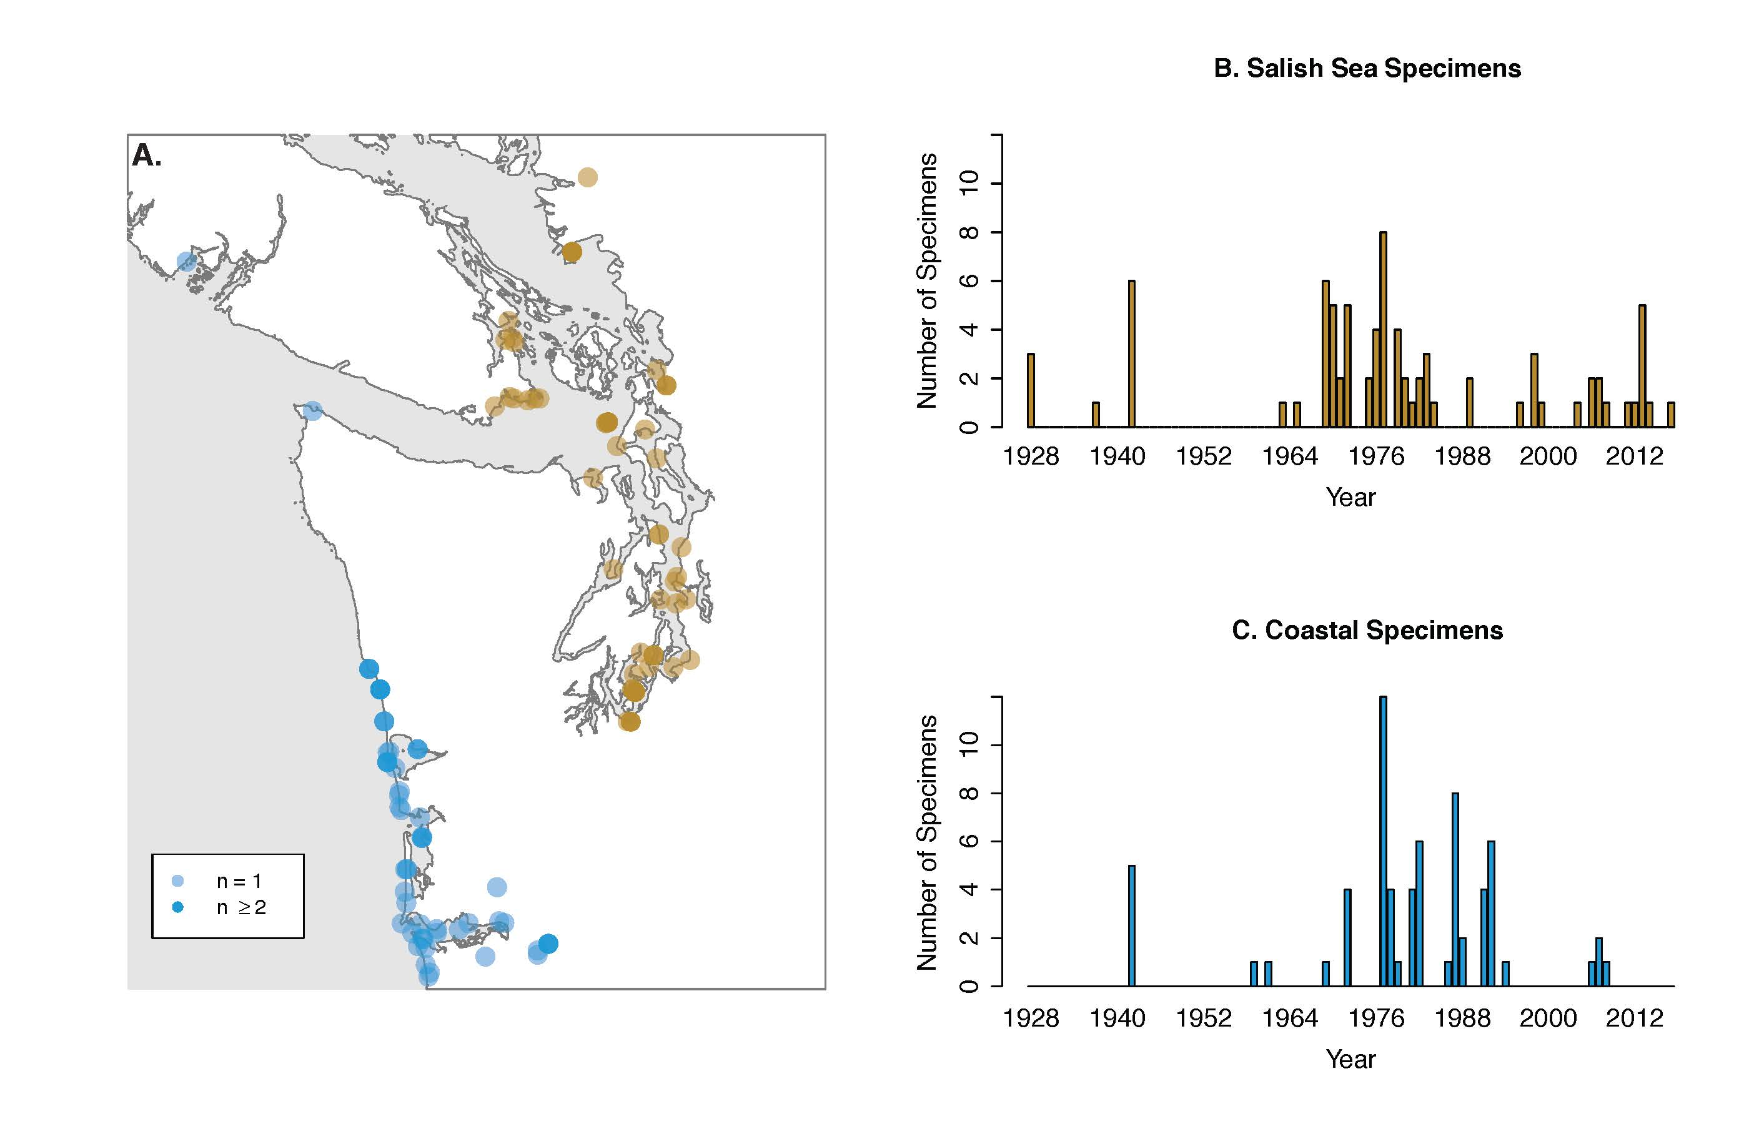

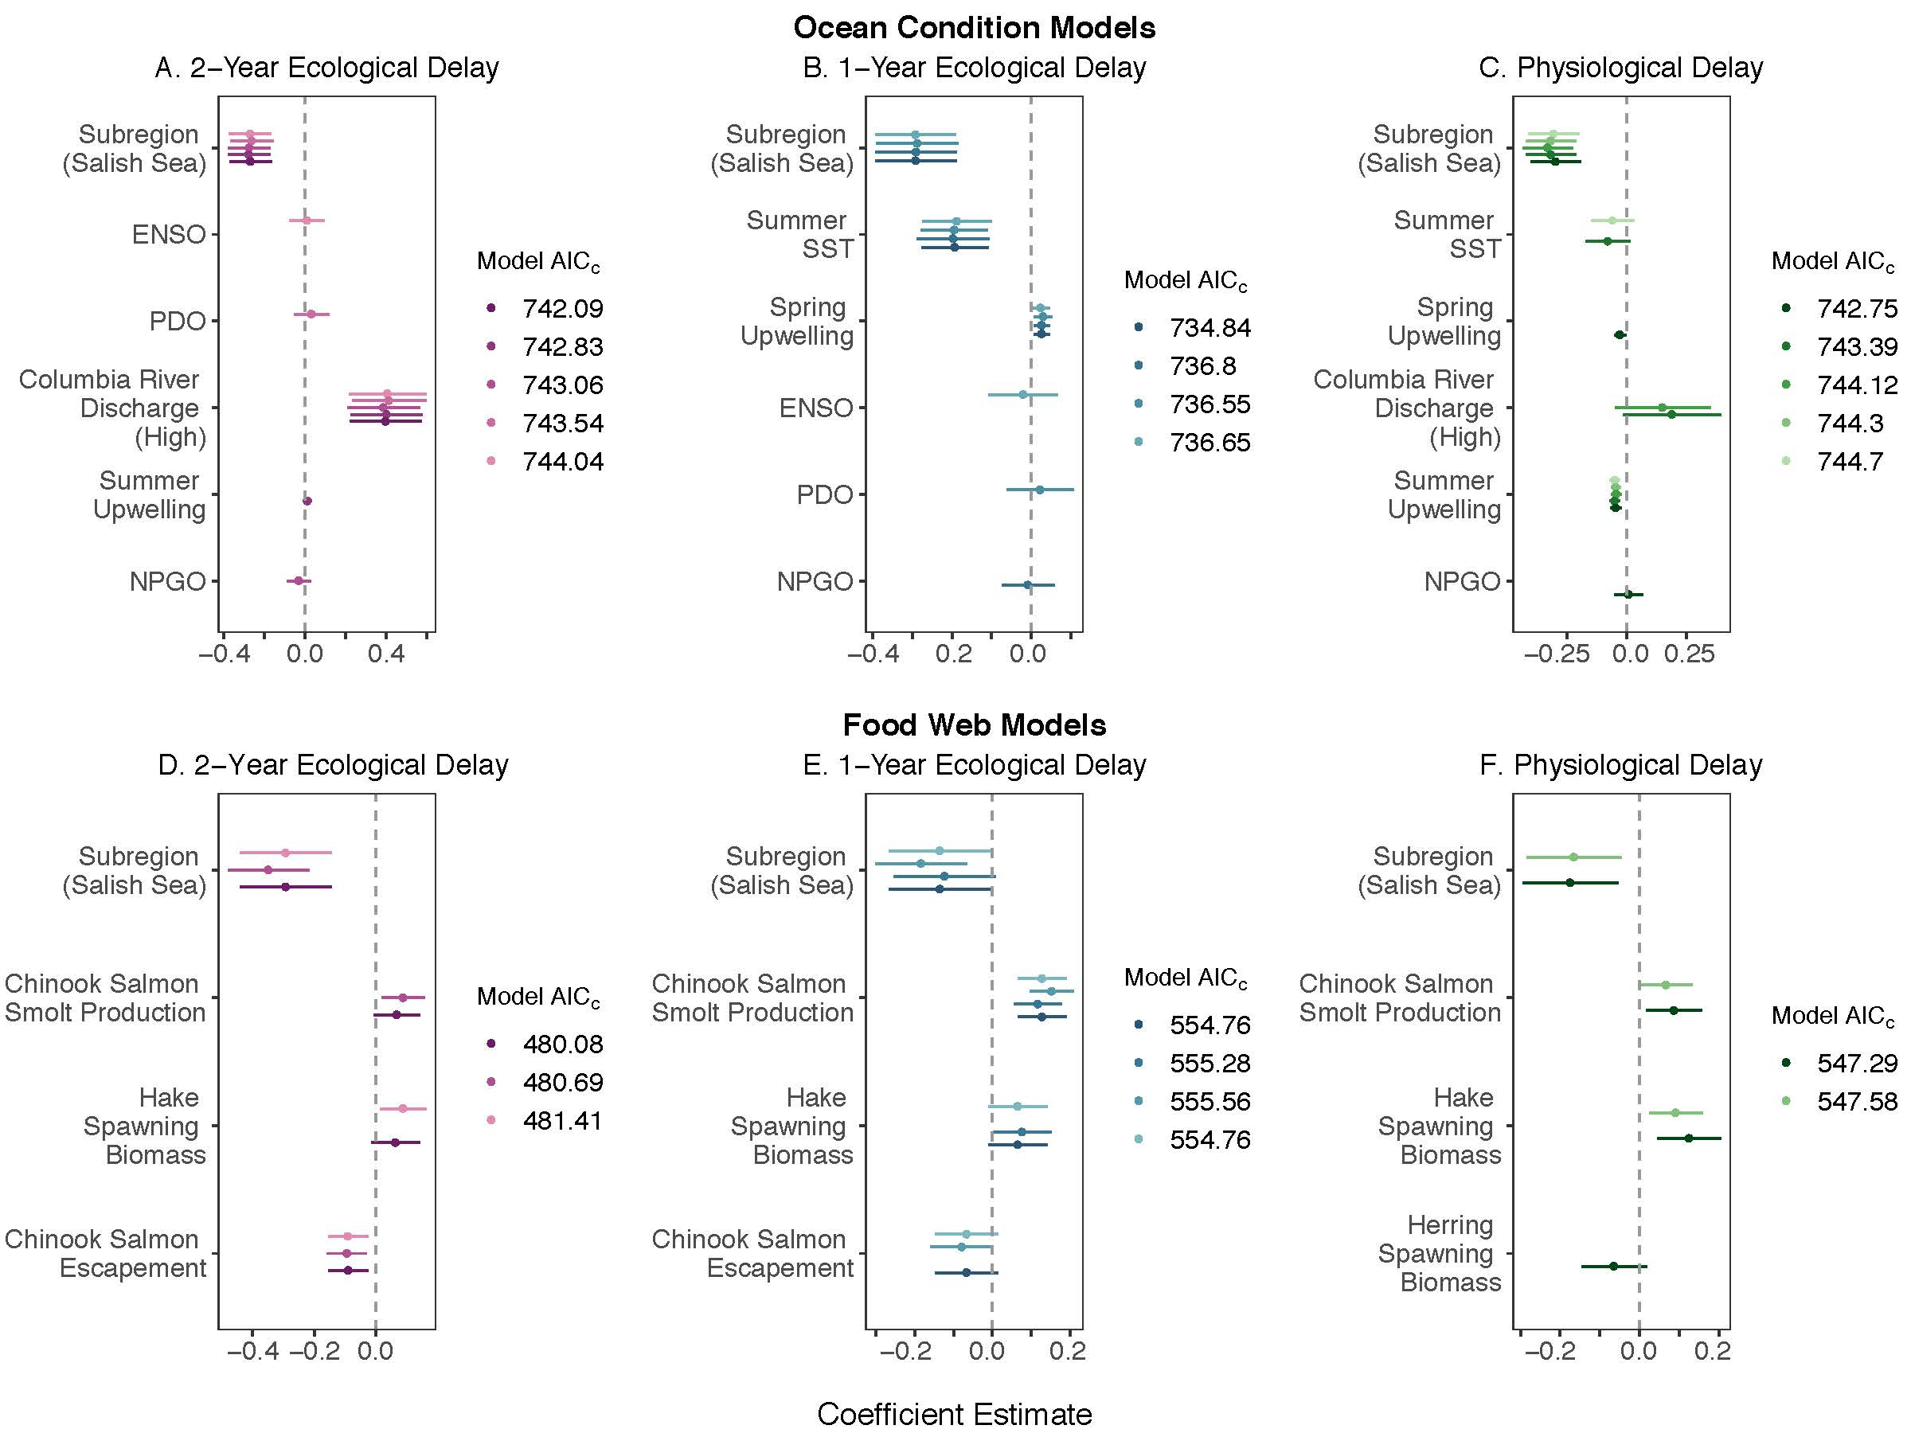**Fig. 2**

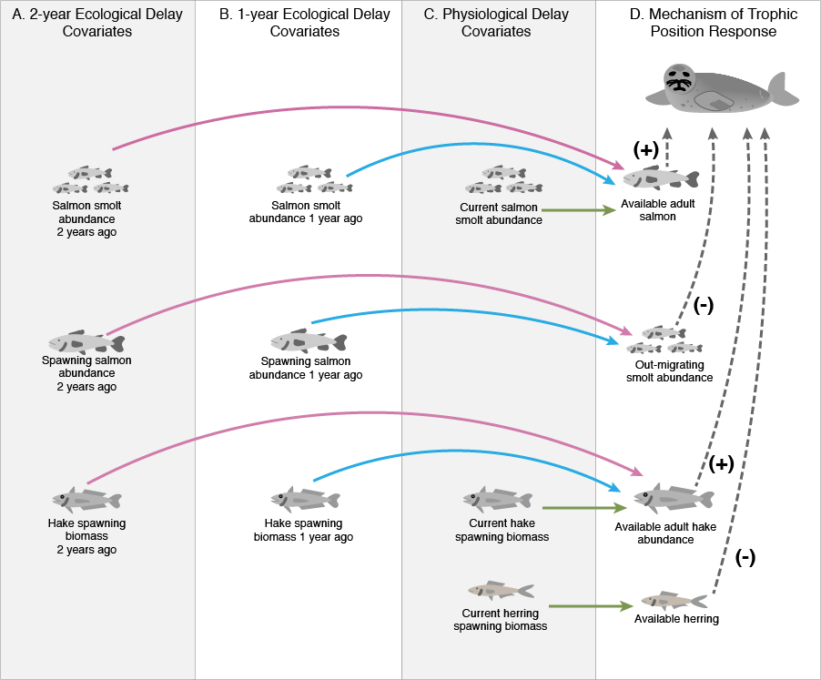**Fig. 3**